Maxima & Minima:

At any point where the graph has slope of 0, then that point said to be maxima & minima.

Slope = 0, means dy/dx = 0.

And using this we can find at what x we get maxima and minima.

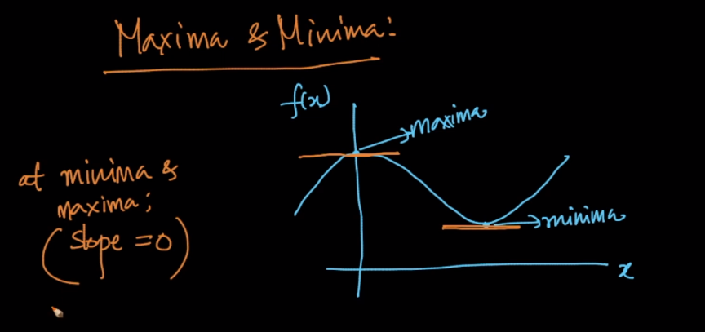

But how to know whether obtained value is maxima and minima.

Let’s say we obtained max and min at x = 1.5,

Then choose a x value closer to obtained value say x = 1.

Therefore for given func f(1) = 0.

Now since f(1.5) !< f(1), therefore at x=1.5 we don’t have minima.

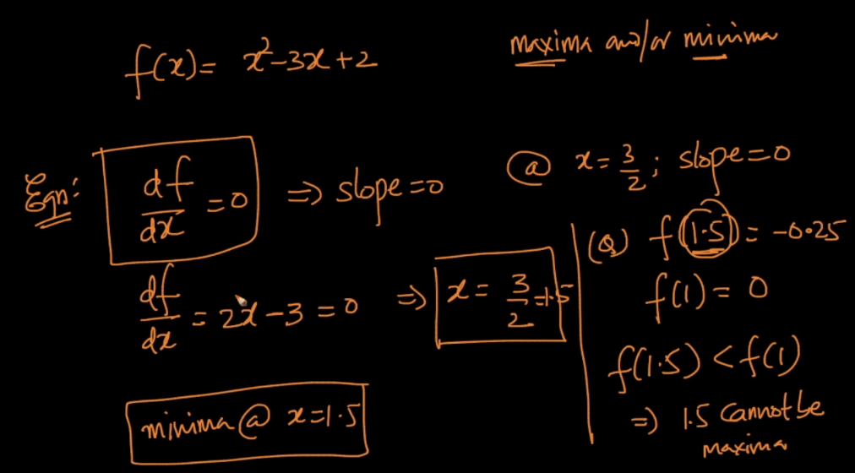

It’s not necessary that every fun has maxima and minima there can be

1. May have Maxima and Minima .  
2. Could have only minima .  
3. May not have both Maxima and Minima.  
4. Multiple Minima Multiple Maxima.  
5.Could have only Maxima .  
6. Can have multiple local maximas, minimas but only one global Maxima or global minima.

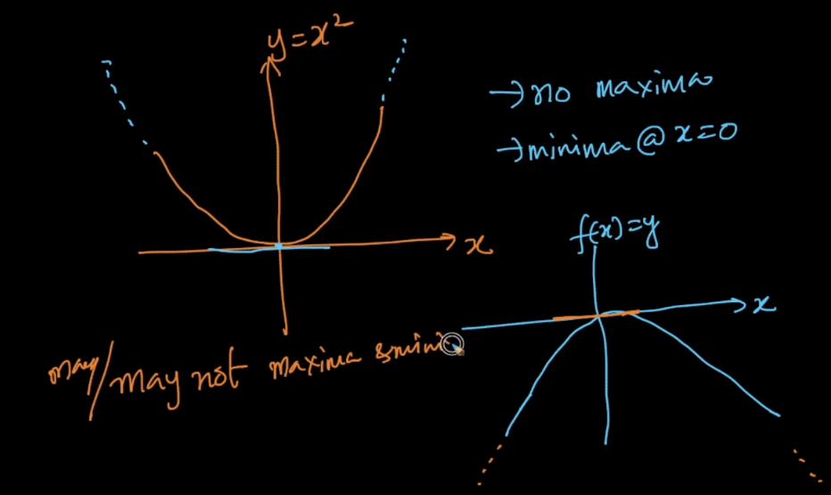

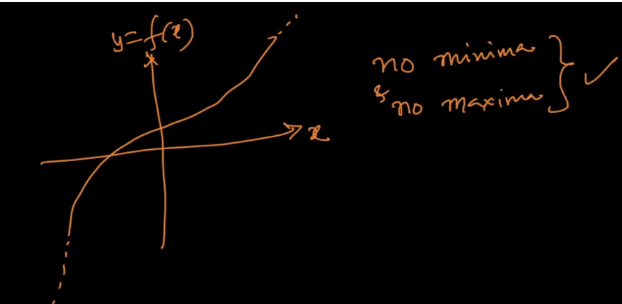

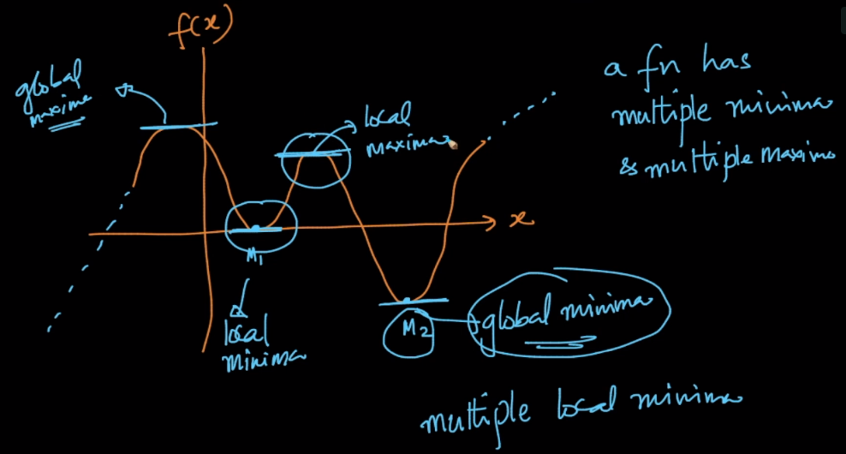

But calculating maxima and minima is not trivial to solve for several functions.

Therefore we use gradient descent which finds minima and maxima without solving this equations.

